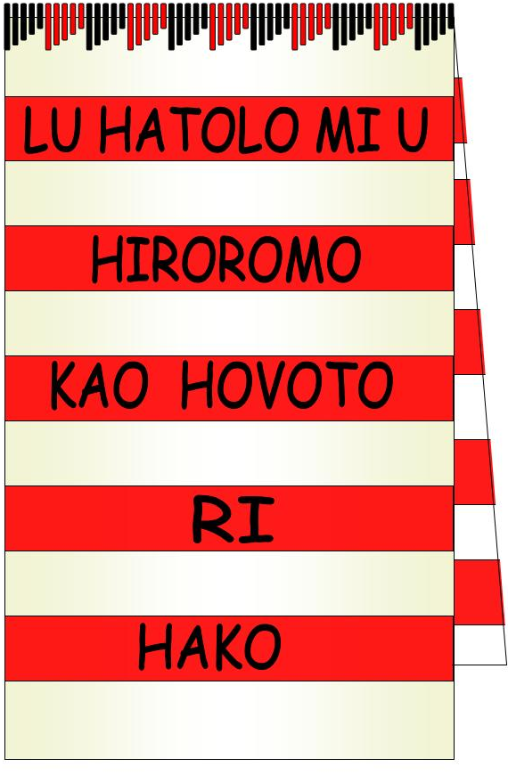
Hako Women’s Collective
P.O Box 699, Buka, Autonomous Region of Bougainville
Contact President Dorcas Gano ph +675 71110760

Women of Hako Developing and establishing with love for Hako
Policy: Countering bribery and corruption
Policy number | 4
Approved by the Board | 19th December 2016
Commenced | 19th December 2016
Last amended | 15th December 2016
Planned revision date | 31st March 2017
Associated instruments/ policies | - Corporations Act 2001 (Commonwealth)  - PNG legislation on Bribery & Corruption  - HWC Constitution

- Overview
Hako Women’s Collective (HWC) has zero tolerance for bribery and corruption.
- Application
This policy applies to all Members.
- Policy
  - HWC recognises that bribery and corruption remain major problems, which undermine the efforts and goals of aid and development, as well as trust in enterprises. Bribery and corruption hurt the poor disproportionately and hinder both economic growth and good governance.
  - Within its capacity and through its work HWC:
    - Includes risks of bribery and corruption as part of its due diligence in undertaking funded projects
    - Establishes robust and transparent financial recording systems
    - Ensures identifiable recording of grants received and expenditure
    - Ensures invoices and receipts are obtained for outgoings and retain these documents for a period of 7 years
    - Makes financial records available to funding organisations on request
    - Monitors projects and funding distributions
    - Ensures partners, staff and volunteers working with HWC are aware of HWC’s zero tolerance policy
    - Collaborates with appropriate authorities to address matters of bribery and corruption
    - Works with its partners to strengthen capacity and culture for bribery and corruption-free operations, and
    - Cooperates with other not-for-profits to share knowledge and practice in overcoming bribery and corruption.

